Course Title: Social Immersive Learning
Course Code: 24UC0021
Name: L.Ishitha
Roll No: 2420030041
Section: 10

Title of the Event:
Career Journey

Organized by:
Department of Career Guidance and Training, KLH University – Bachupally Campus

Dates:
September 20, 2025 | 10:00 AM – 2:00 PM

Event Summary:
“Career Journey” is an insightful event designed to help students navigate the various stages of building a rewarding and meaningful career. It focused on essential aspects such as self-discovery, skill enhancement, goal setting, and adapting to the evolving job market. The sessions were led by industry experts and faculty mentors who shared valuable guidance on career planning, interview preparation, and developing a growth mindset. The event motivated participants to align their personal strengths with their professional ambitions, fostering confidence and clarity in their career choices. It served as a roadmap for students to pursue their aspirations with determination and purpose.

Key Highlights:
- Motivational talks from industry professionals and alumni on career development.
- Interactive workshops on resume building, communication, and leadership skills.
- Guidance sessions on identifying personal strengths and setting achievable goals.
- Discussions about industry trends, emerging technologies, and future job opportunities.
- Encouragement to maintain a balance between personal interests and professional growth.

My Participation:
I actively participated in the Career Journey event and attended sessions that focused on self-assessment, goal setting, and future skill development. The speakers shared real-world insights into how one can adapt to changing career landscapes while maintaining passion and purpose. Through these sessions, I learned the importance of networking, continuous learning, and developing both technical and soft skills. This experience helped me gain a clearer perspective on my career goals and the steps needed to achieve them.

Event Photographs:
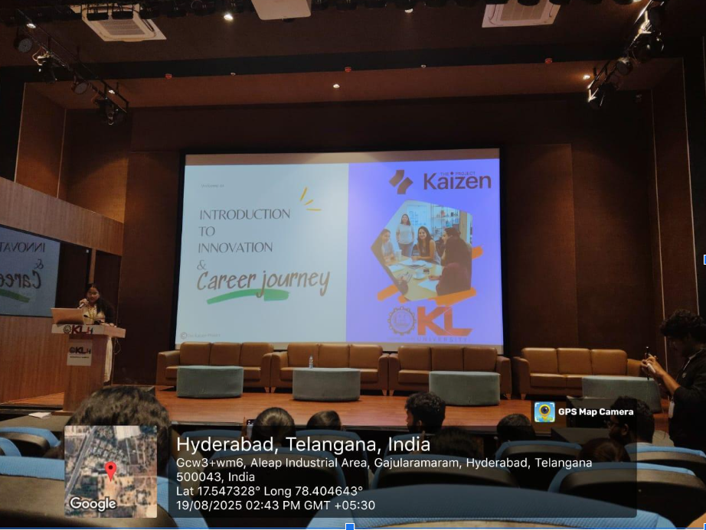

Conclusion:
The “Career Journey” event was an enriching experience that provided valuable guidance on professional development and personal growth. It encouraged me to take proactive steps toward career planning, identify my strengths, and stay committed to lifelong learning. The sessions helped me gain confidence in making informed decisions about my future career path.

Acknowledgment:
Special thanks to KLH University and the Department of Career Guidance and Training for organizing the Career Journey event and offering valuable mentorship and direction to students in shaping their professional futures.

